CS 255 System Design Document
Ashley Hensley
6/21/2026

UML Diagrams

UML Use Case Diagram
Below is the UML Use Case Diagram for the DriverPass System. This diagram shows the users of the system: Student, Secretary, Admin/IT Officer, Driving Instructor, and the DMV System. Inside the boundary are the use cases needed for the system to work, and each use case is related to one or more users as shown by the lines drawn.

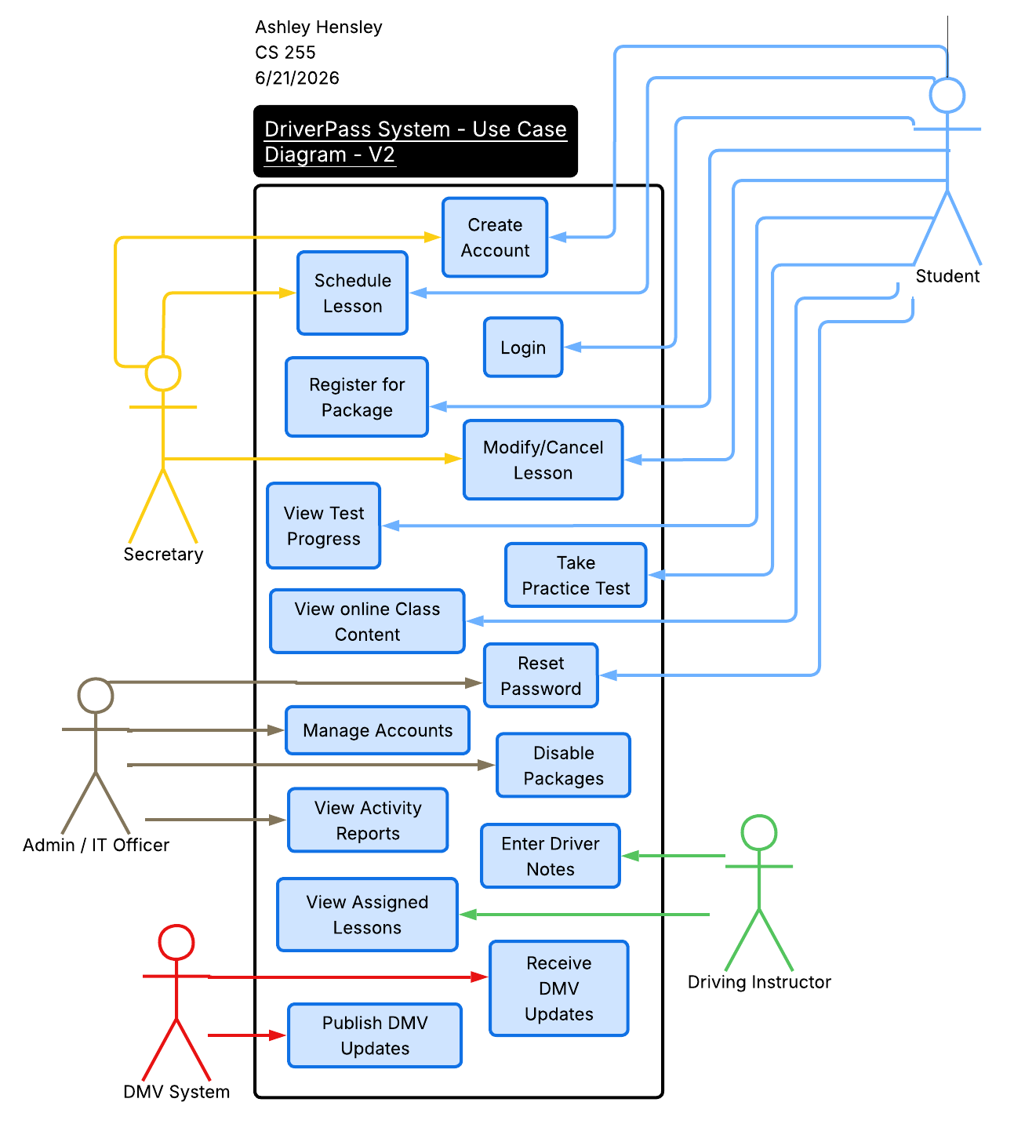

UML Activity Diagrams
Below are two UML Activity Diagrams created from individual use cases found in the Use Case Diagram.

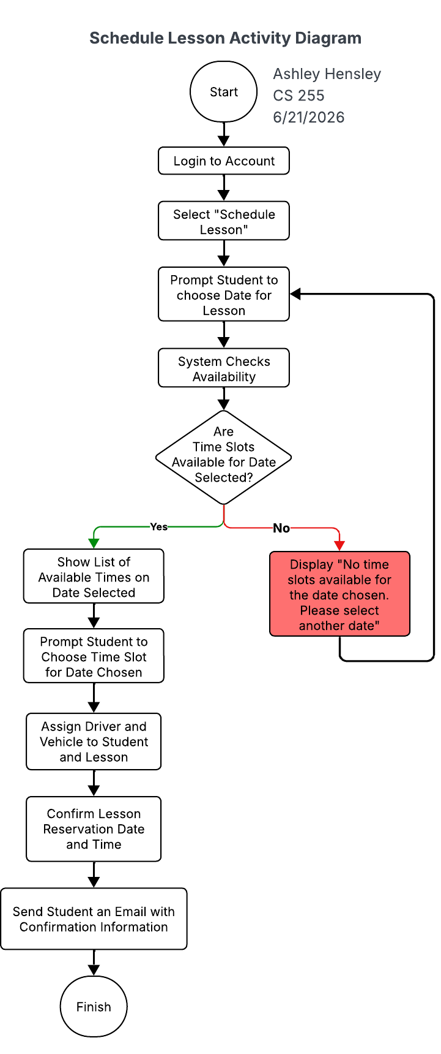
1. The first is an Activity Diagram for the “Schedule Lesson” use case. This diagram shows the process of scheduling a lesson from start to finish as would be done by a secretary or student. The diamond indicates a choice, namely here if time slots are available for a selected date, and what happens depending on if the answer is “yes” or “no”. There is a loop after “no” indicating that there was not an available time slot for a selected date, so a message is shown to the user and they are again given the prompt to choose a date.

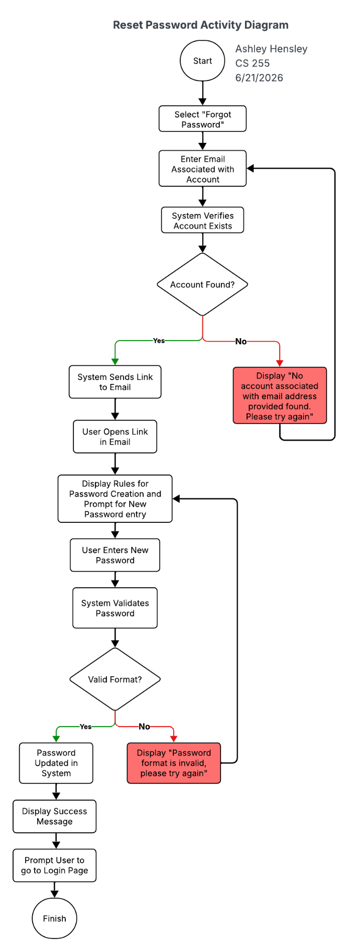
2. The second use case I created an Activity Diagram for is the use case “Reset Password” that can be completed by an IT Officer or by a student. This process includes two loops, one for ensuring that an account is found using the email the user enters, and a second for making certain that the new password being created matches the formatting required for a password within the system.

UML Sequence Diagram
The UML Sequence Diagram use case that I chose was again “Schedule Lesson”, as this is an integral part to the DriverPass system. This diagram focuses on the relation between actions in the process and the different initiators of those processes too. For instance, the Student or Secretary will login, which communicates with the System. The System then communicates with the Scheduling Service to verify login credentials, and the Scheduling Service sends back a verification if valid. This continues throughout the process in the diagram to make the steps clear and laid out in a timeline-like fashion.

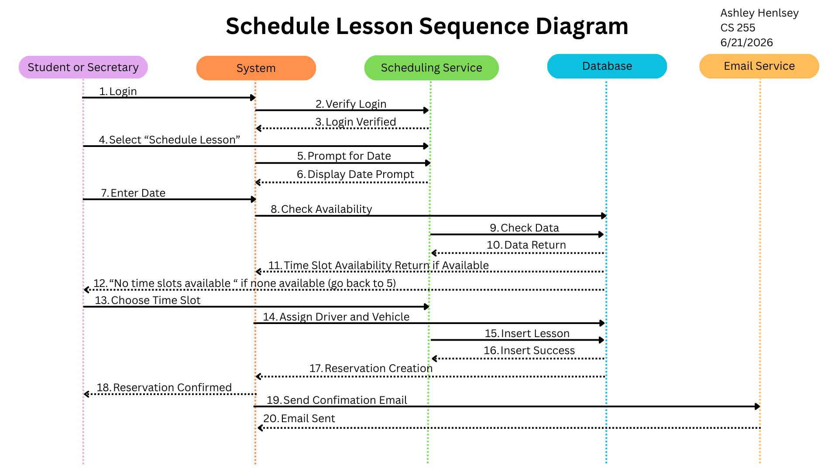

UML Class Diagram
The UML Class Diagram is more for communicating the developmental side of the system. Each bubble below is a class, and each class has attributes which are private as indicated by the “-“ symbols. The second section of the bubbles will be for methods for each class.
The classes have relations to one another as indicated by the lines in between. These relations also indicate a numerical value for each instance of a class. As an example, for each instance of Student, there will be one instance of PaymentInfo as indicated by the little “1”’s on the line between the two classes. This is because each Student can only have one payment info at one time. On the other hand, each instance of Student can have many instances of PracticeTest, because they can take many practice tests.
Some classes stand alone, such as DMVUpdates, Secretary, and ITOfficer.

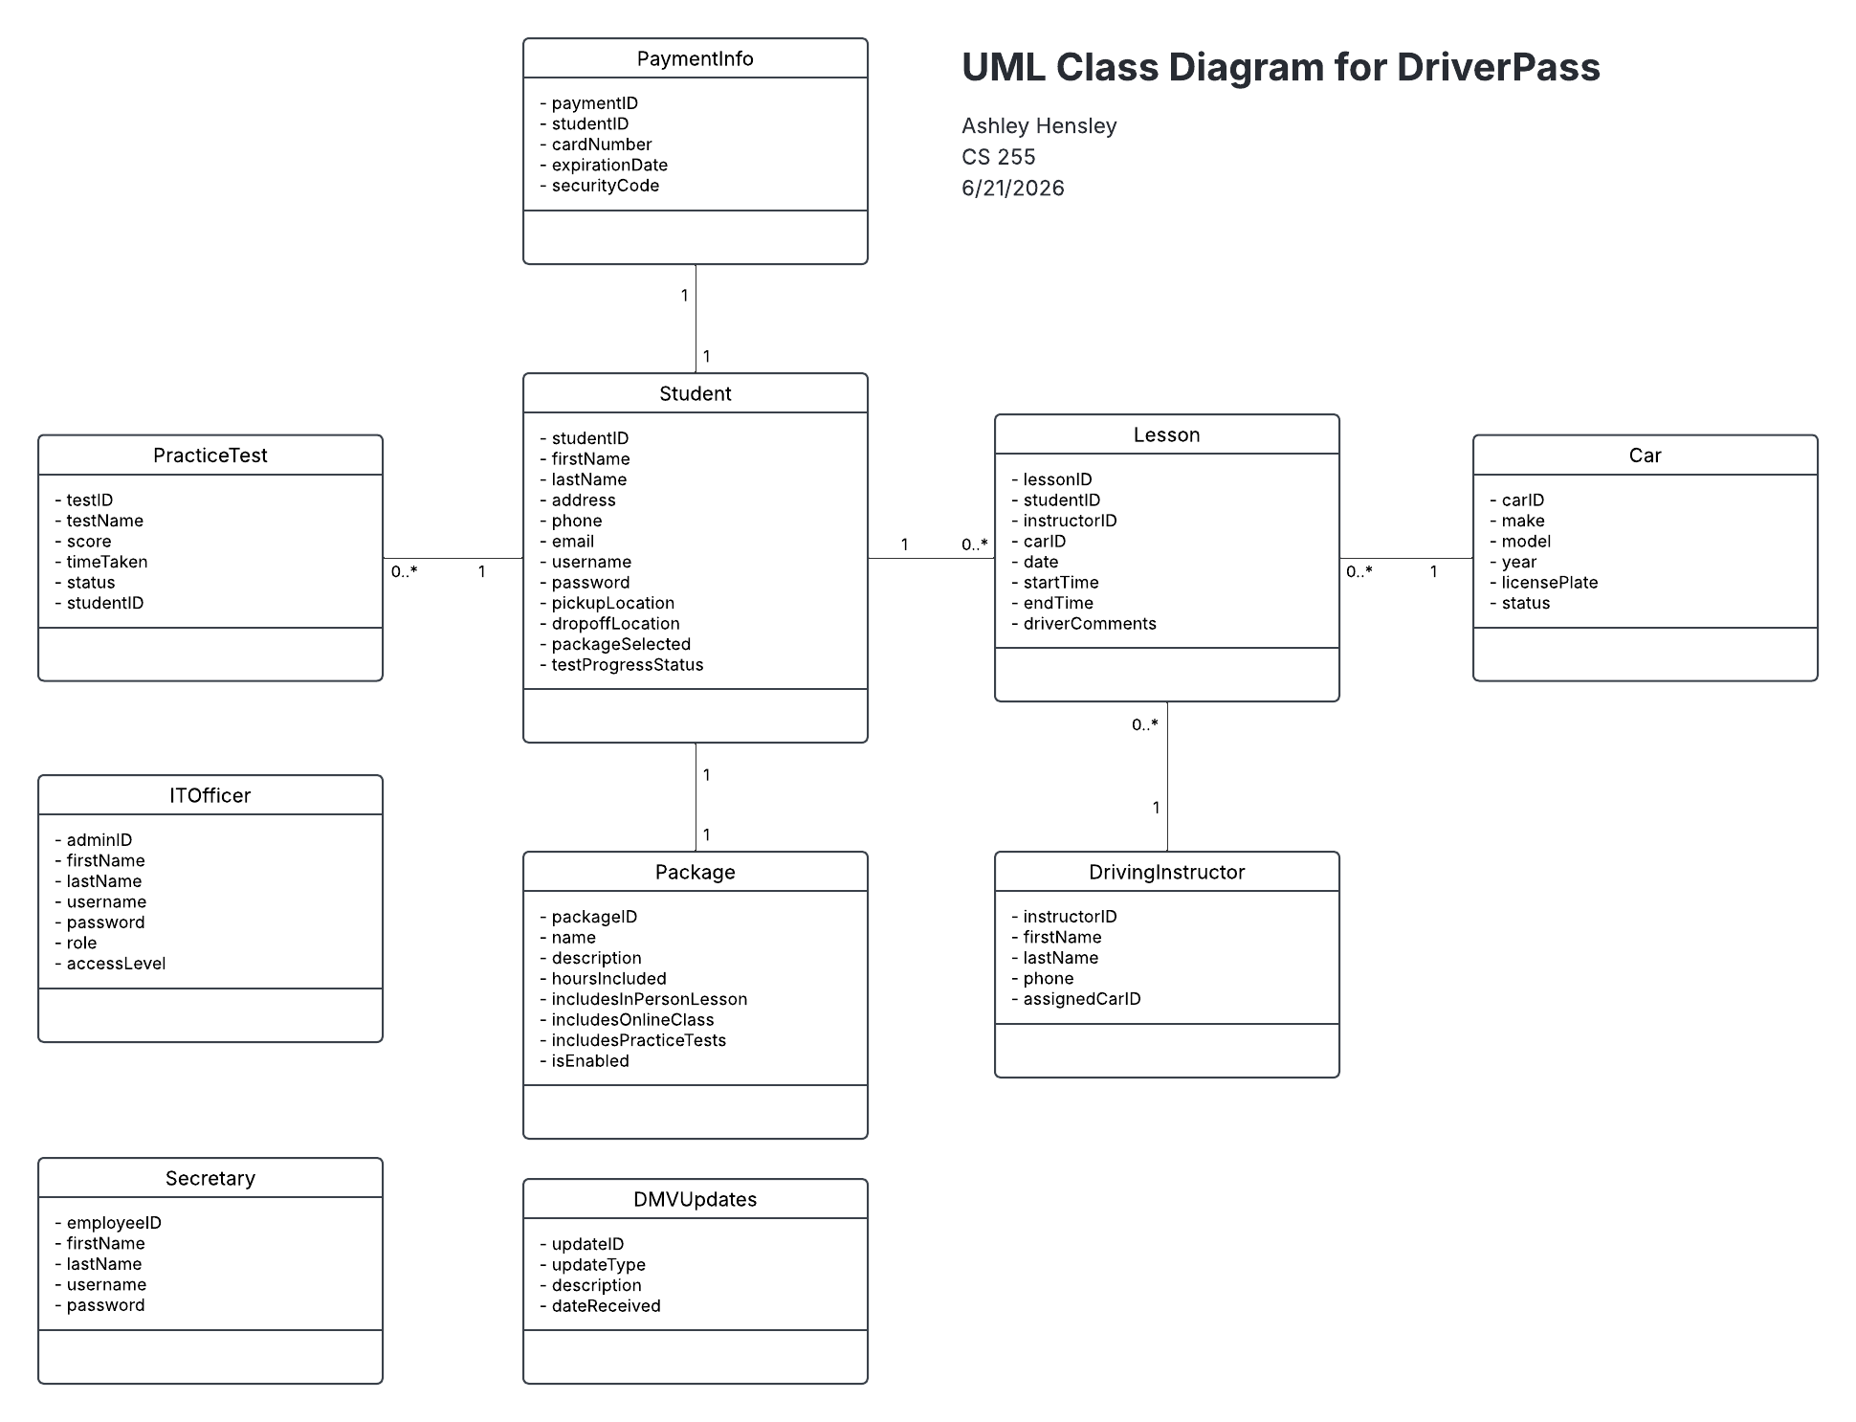

Technical Requirements
The technical requirements for the DriverPass system include hardware, infrastructure, and software requirements and developmental tools that are needed to support the cloud-based scheduling and online training platform requested. The various functions of the system, such as the lesson scheduling and administrative function, as well as what is necessary for a cloud-based hosting system with security, scalability, and performance are all impacted by the technical requirements.
Hardware Requirements
These requirements communicate what is necessary for performance, availability, and security in terms of using the system.
Client Hardware Requirements
- Any modern desktops, laptop, tablet, or mobile device that can run a web browser and supports HTTPS
- A minimum of 4 GB RAM and a reliable internet connection
Server-Side Hardware Requirements
- Virtual, cloud-based servers with proper CPU and memory capabilities that are also scalable
- Ample and proper storage for user accounts, test data, etc.
- Infrastructure that is load-balanced and can support 99% uptime and 2-3 second response times
Software Requirements
The software requirements support was necessary for important functional aspects of DriverPass such as scheduling, practice tests, and role-based access.
Client Software Requirements
- Most modern web browsers, especially: Chrome, Firefox, Safari, Edge
- The browser must be able to support secure HTTPS connections and JavaScript, CSS3, and HTML5
Server-Side Software Requirements
- A web application framework such as Java, Python, or .NET
- A relational database management system such as MySQL for storing data, including activity logs, user accounts, lesson schedules, etc.
- Integration with an email service so that passwords can be reset and reservation confirmations can be sent
- Role-based access control software that utilizes secure authentication
Developmental Tools
The nonfunctional requirements for DriverPass need certain tools for maintainability, scalability, and adaptability. Some of these include:
- An IDE for building the web application itself such as Visual Studio Code or Eclipse
- A version control system for handling code changes, like GitHub
- Testing tools are necessary for unit testing, testing browser compatibility, and integration testing
- One developmental tool used for this document was LucidChart for creating the UML Diagrams
- A tool like Excel for exporting APIs to support offline data analysis for the Owner
Infrastructure Requirements
The nonfunctional requirements also have infrastructure requirements to ensure system security, accuracy, platform constraints, and adaptability.
Cloud Hosting
- A cloud hosting platform to host the web application such as Azure or Google Cloud
- Auto-scaling capabilities for scheduling
- Automated backups for the cloud-based database
- Encrypted communication is a must, so secure HTTPS certificates are required
Infrastructure Security
- Using HTTPS or TLS for encrypted data transmission
- Secure credential storage and password hashing
- Account lockout for if multiple logins are attempted
- Role-based access for all users, specifically: students, drivers, secretaries, IT staff, and the owners
- Data logging and monitoring tools to check scheduling conflicts, failed login attempts, and system errors in general
Infrastructure Integration Capability
- Automated feed for DMV updates
- Integration with an email service for resetting user passwords and lesson scheduling confirmations

